# DSP Lab Final Project Proposal

## Project topic: Guitar Simulator

Group member: Jingyuan Li(jl10915), Zongying Liu(zl3079)

Our guitar simulator project is designed to play guitar sound in real-time when user press the keyboard. User can choose different chords through a GUI.

Here is the preliminary interface of our guitar simulator system.

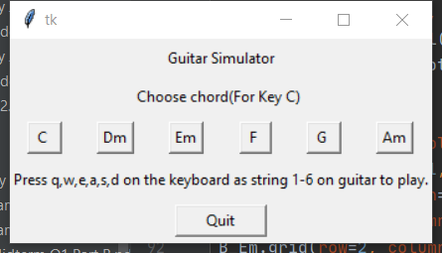

The choosing chord buttons are connected to a changing chord function which can change the sound frequency of the six strings of guitar. This function requires the text on the buttons as input parameter and can change the sound frequency of each string corresponding to the chosen chord button.

After choosing the chord, user should press the q, w, e, a, s, d on the keyboard to simulate plucking the guitar string, and the system will play the sound by applying Karplus-Strong algorithm to the original sound in real-time related to which key was pressed. There is a difference equation (filter) to implement each note as the original sound for Karplus-Strong algorithm.